JNNCE CSE– APP Store

**App Name: Droid Assist**

**About App**

Droid Assist helps students gather all their study materials and resources gather at a single place. This mainly helps facilitate the online education flow a little smoother. The student can keep track of their attendance as well their scores in the assessment conducted. The student can also view the resources of the subjects they are enrolled in. Along with this they can view their timetable.



**Sample Output Snaps**

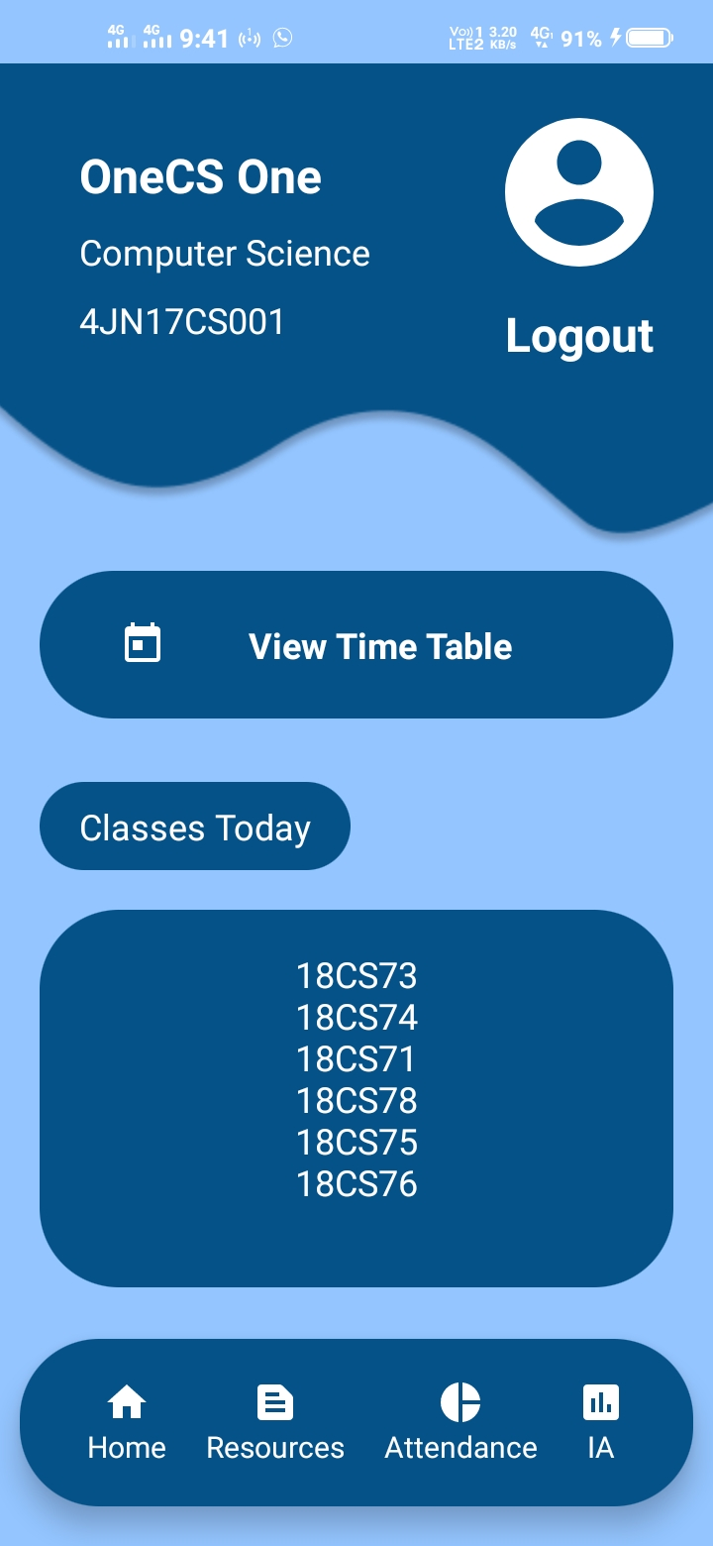

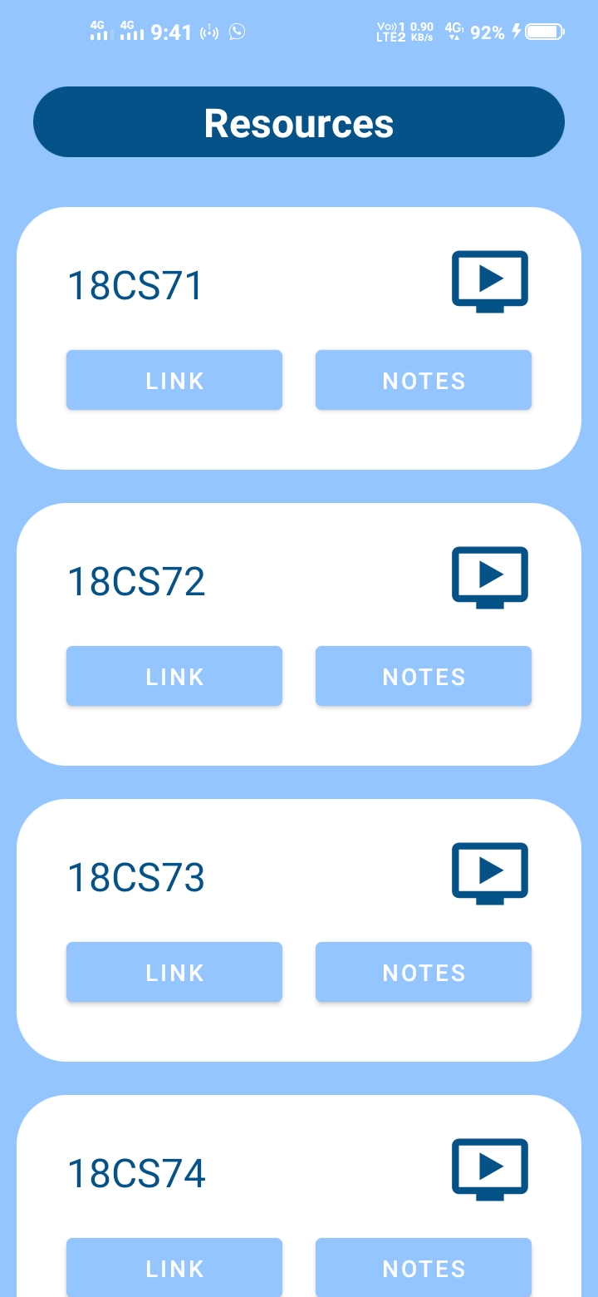

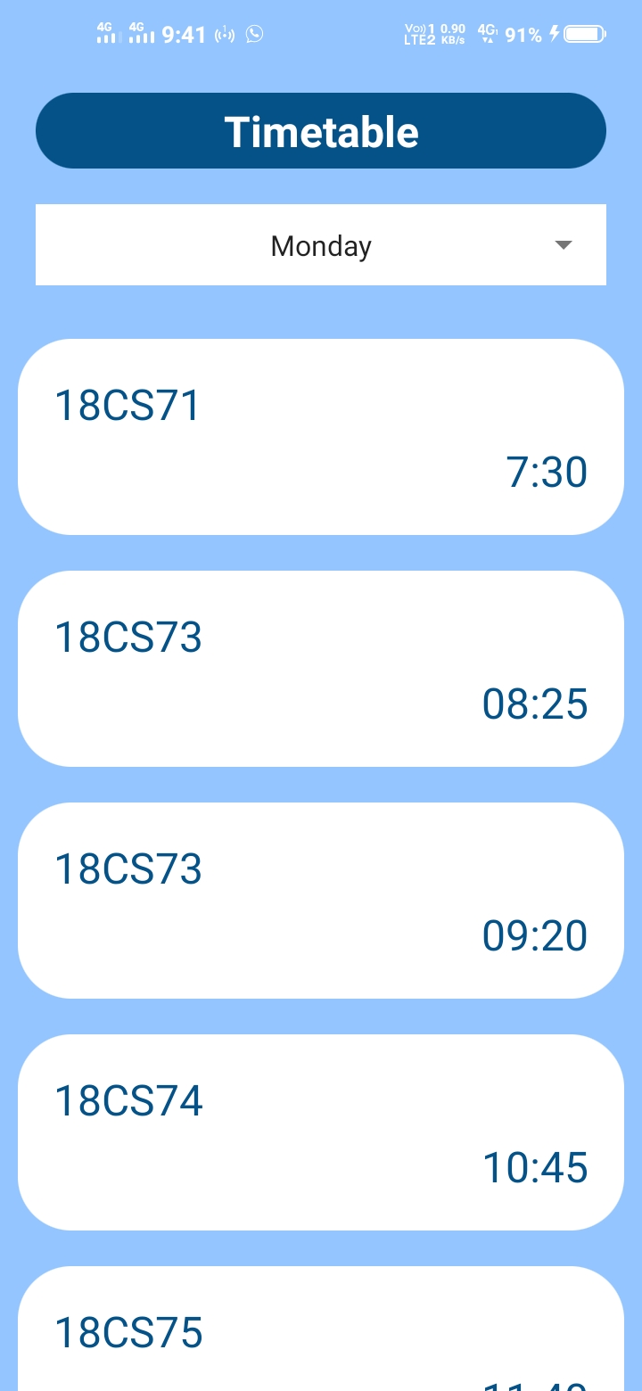

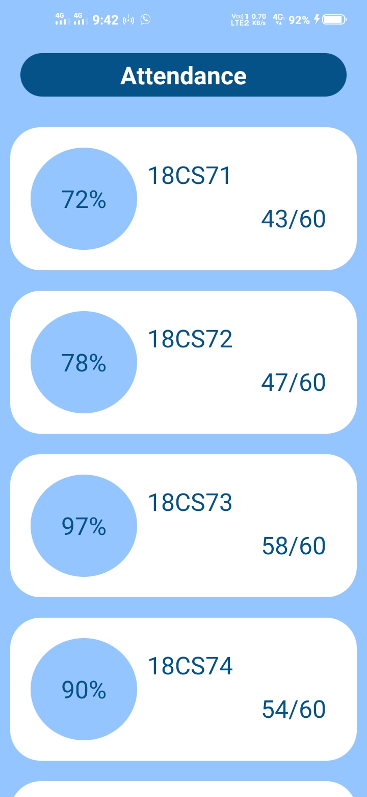

**Developer Contact**

|  |  |  |
| --- | --- | --- |
| 4JN18CS048 | 4JN18CS128 | 4JN19CS403 |
| **Mohammed Moin Mirza** | **Zaheer Abbas** | **Chetan B A** |
| **mirzajr9@gmail.com** | [**nk4456542@gmail.com**](mailto:nk4456542@gmail.com) | **chethanbirugundi@gmail.com** |
| **7618779823** | **9845297758** | **9341985926** |
|  |  |  |